**Asteroids ECS**

by Leandro Wainberg

Unity version: 2020.3.30f1

ECS version: 0.51.1-preview.21

<https://github.com/leandronw/AsteroidsECS>

UFO’s Obstacle avoidance

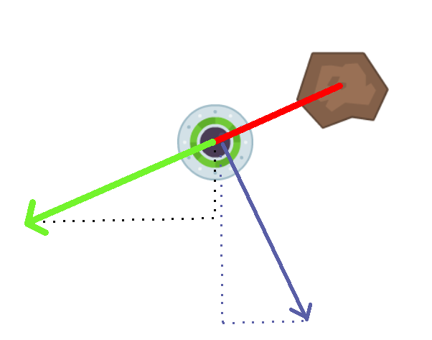

The UFO implements a very basic algorithm to avoid asteroids (in UFOMovementSystem). Its parameters are in the UFOBrainComponent. Every “MinTimeSinceLastChange” seconds, it checks all asteroids that are closer than “MinDistanceToCheckObstacle”.

The red line represents the “difference” vector between the UFO and the obstacle. With that information, it obtains the “oppositeForce” (represented as the green arrow), which is the ideal velocity to avoid that obstacle. Its length is inversely proportional to the “difference” length, because as the asteroid gets closer, the longer the “oppositeForce” should be.

Since the UFO always go in the same X direction (from left to right or from right to left), if the asteroid is in the direction the UFO is heading, in order to avoid the asteroid the “oppositeForce” needs its axes swapped, giving the blue arrow as result.

This vector is calculated for all obstacles that are closer than MinDistanceToCheckObstacle and added together, and the result is normalized and multiplied by the UFO’s speed, giving the final new velocity.